

**UNIVERSITY OF PETROLEUM AND ENERGY STUDIES**

**School of Computer** **Science**

**2020-21**

**GRAPHICS AND ANIMATION TOOLS LAB**

**Faculty: Dr. DURGANSH SHARMA**

**Assistant Professor**

**Department of Cybernetics.**

**School of Computer Science, UPES**

**Submitted By:**

**Name- Ishita J Karmakar**

**Roll no-R100217107**

**Batch-B3**

**Semester- 7**

**Course-B.Tech CSE-OSOS**

**SAP ID- 500064067**

**FINAL PROJECT**

**(A SMALL VILLAGE SCENE)**

**STEPS:**

1. Open Blender workspace delete the existing cube and Click on the add option and then add a cylinder.
2. Then we will make some adjustments in the cylinder like radius and depth, we will set the depth and radius as 2m and set cap fill type to nothing.
3. After making changes in the cylinder we will select the upper face of cylinder and then extrude it.
4. After the above step we will shape that extruded region like the upper part of the hut using scale option.
5. For creating a door, we are going to select any front face of the cylinder and then delete it using X key.
6. For creating the structure of tomb of the hut, I have added some more mesh like Torus and Ico Sphere.
7. Similarly create few more huts, for the village scene.

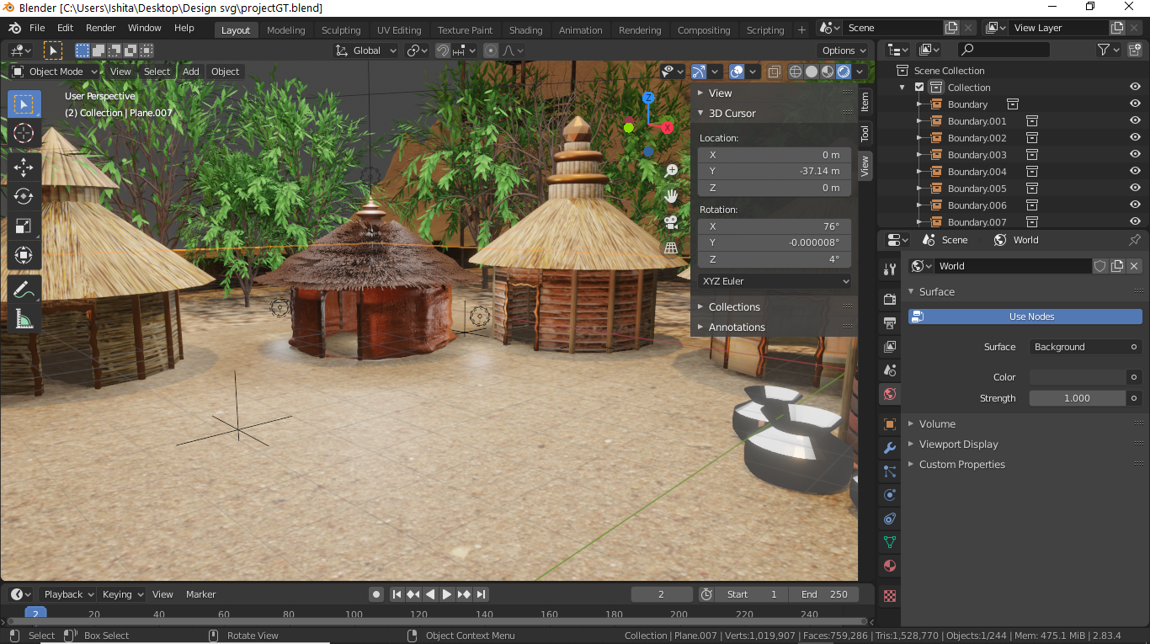

1. Now to make a well, add a hollow cylinder, add few pots around it. Pots can be made by adding cylinder and making few modifications in the edit mode.

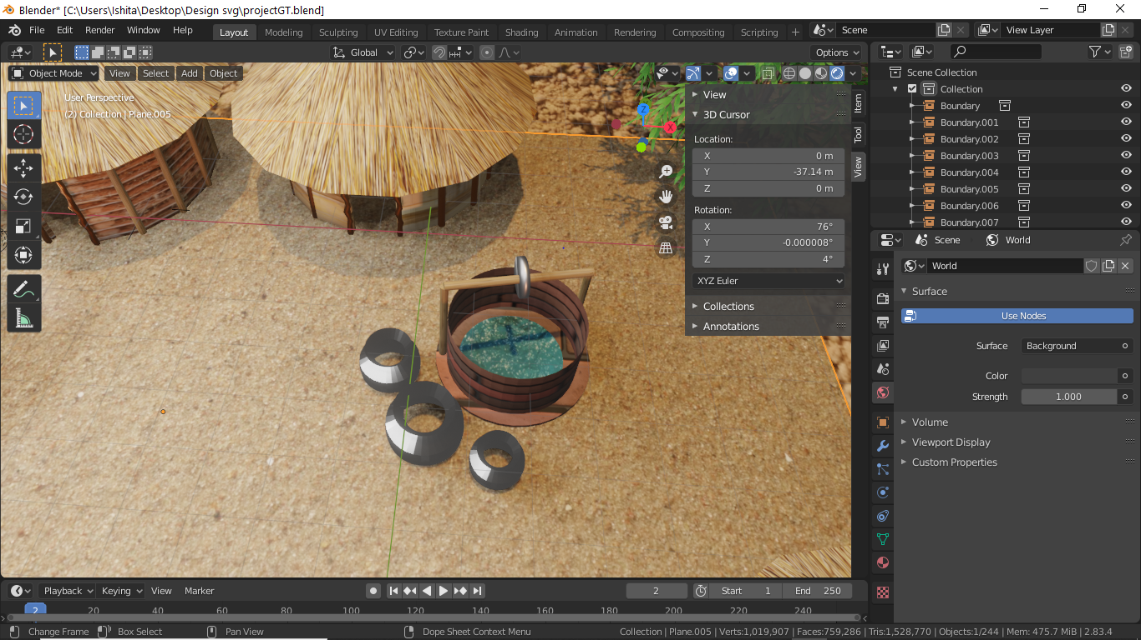

1. Add trees, by selecting sapling trees option in the Add Curve section. Make modification in the amount of leaves and shape of leaves as per requirement.
2. Create many trees with the similar process.

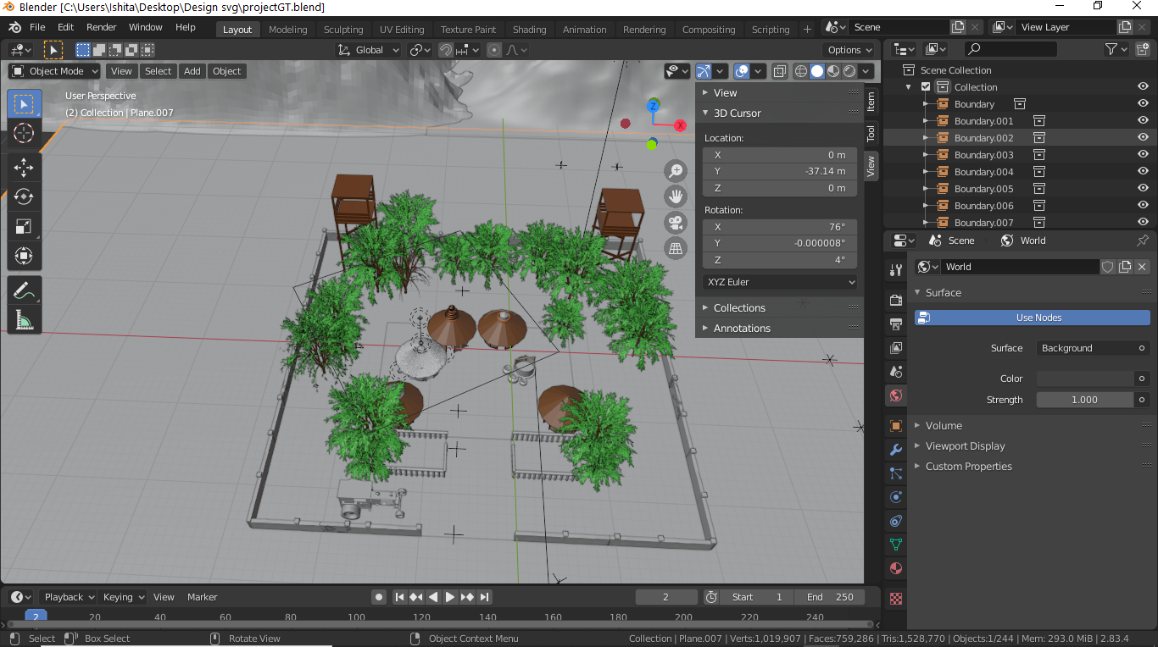

1. For the tractor, add a cube and go to edit mode.
2. Delete the half part of the cube and add a mirror modifier to the cube.
3. Download an image of tractor, Press Shift+A to add an image in the background.
4. No go to X ray mode of the cube. By using extrude and scaling shape the cube as per the image of car.
5. Now take a Bezier circle for the wheel. By extruding and scaling add features to the wheel.

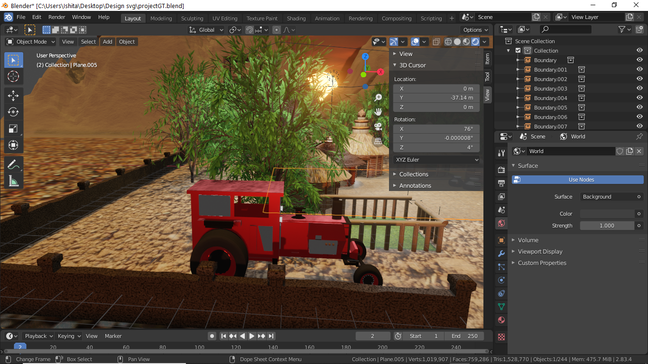

1. For the Mountains, Go to Edit Menu and select ‘Preferences’ option. Select Add-ons in the appeared dialogue box, then tick the ‘Add-Mesh-Landscape’ option.
2. Now go to Add Mesh, and then add Landscape.
3. In the Add Landscape dialogue box, change the settings as per preference in order to make the mountain more realistic.
4. Add another landscape, to add more scenic beauty. Repeat the Step 18 for this landscape too.
5. Add a plane in the background and in the surface.

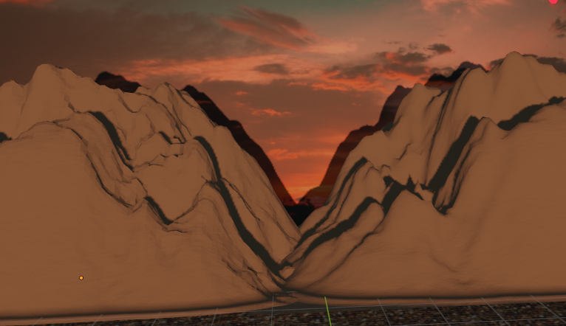

1. For the boundary of the village add a cube, resize it and extrude the required regions.
2. For the Sun, add a UVsphere and add emission properties to it. Select the material color as orangish yellow, to give more realistic effect.

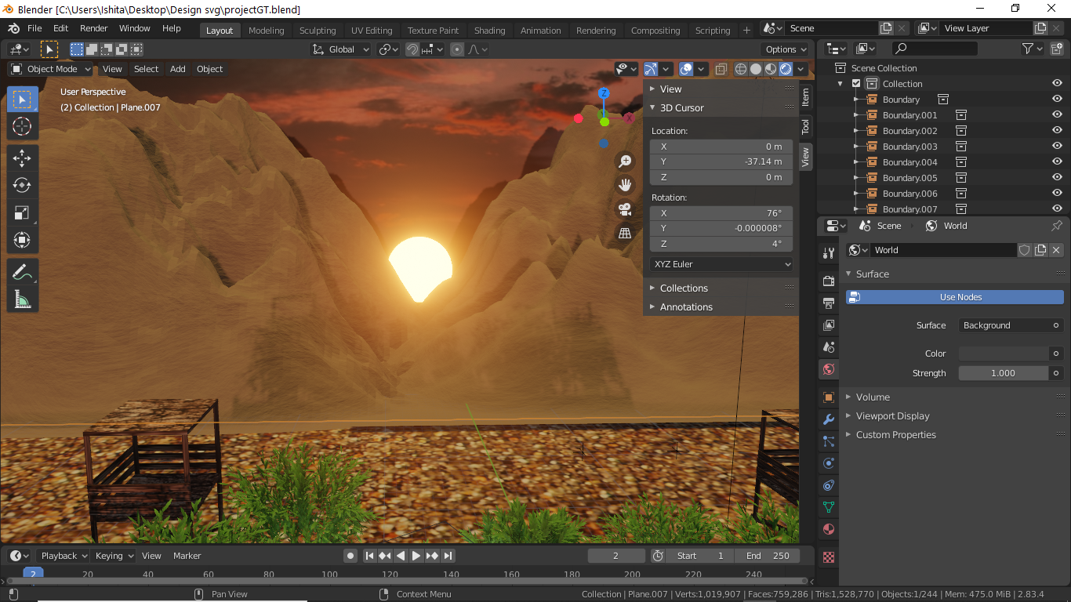

1. Add textures as per requirement.
2. Now render the final model.

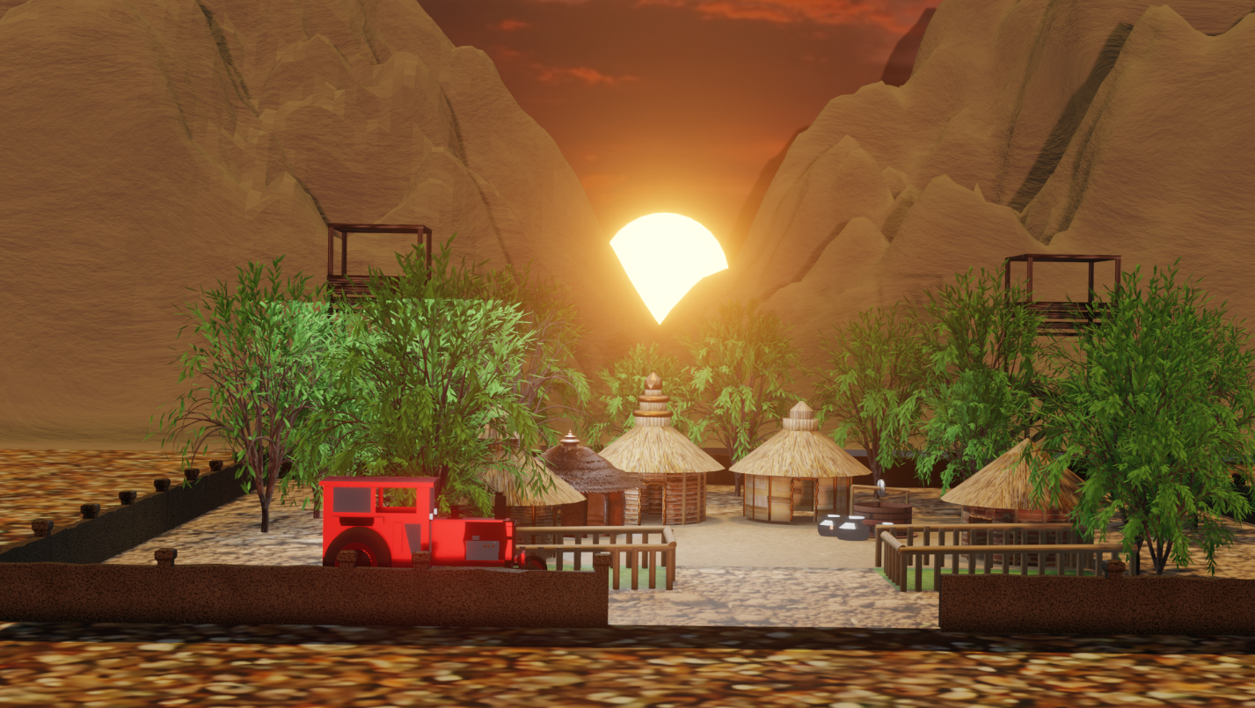

Link for Google Drive: - <https://drive.google.com/drive/folders/1Gd_jKOrGrvM9_Ub-kQktaFxQLeNKz7kb?usp=sharing>